**Class:** Final Year B.Tech(Computer Science and Engineering)

**Year:** 2025-26 **Semester:** 1

**Course:** High Performance Computing Lab

**Practical No. 2**

**PRN :- 23520006**

**Name : Vivek katkar**

**Batch :- B6**

**Title of practical: Study and implementation of basic OpenMP clauses**

Implement following Programs using OpenMP with C:

**Problem Statement 1: Vector Scalar Addition**

**Screenshots:**

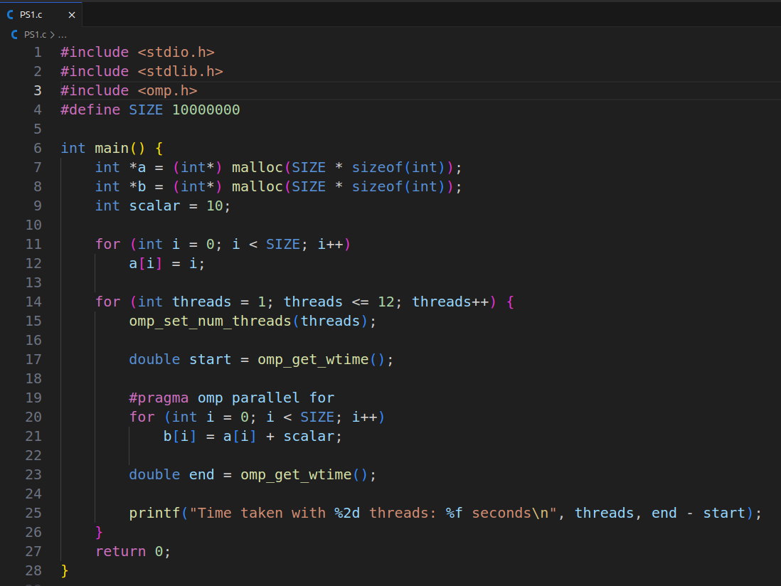

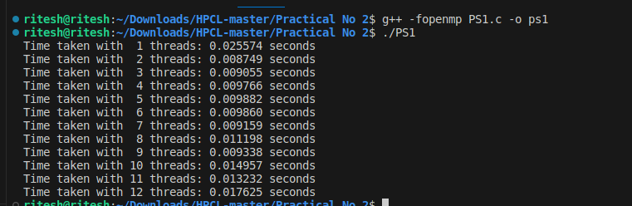**Information & Analysis : *As we have 6 physcial core so we can see the decrease in time*** *but when we are go in form the 7 to 12 there is slight increase in time the reason is the thread scheduling overhead.*

**Problem Statement 2: Calculation of value of Pi**

**Screenshots:**

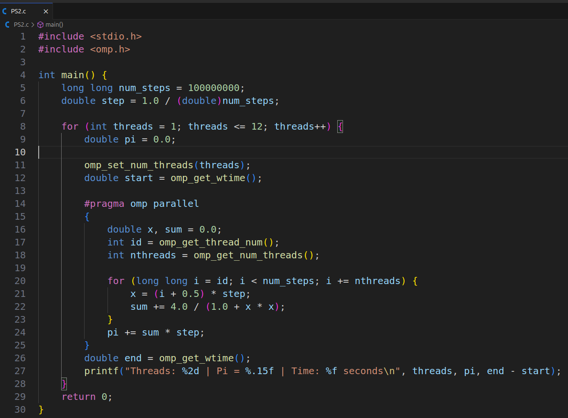

**Information & Analysis: *As we have 6 physcial core so we can see the decrease in time but when we are goin form the 7 to 12 there is slight increase in time the reason is the thread scheduling overhead.***

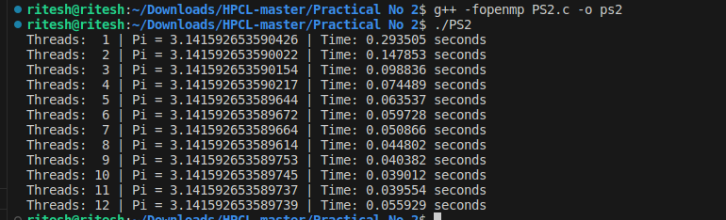

**Github Link: https://github.com/vivekkatkar/hpcl**